6 – WebApi-HandsOn
Code Snippet for Hands-On 1: Console Chat Consumer App (Program.cs) –
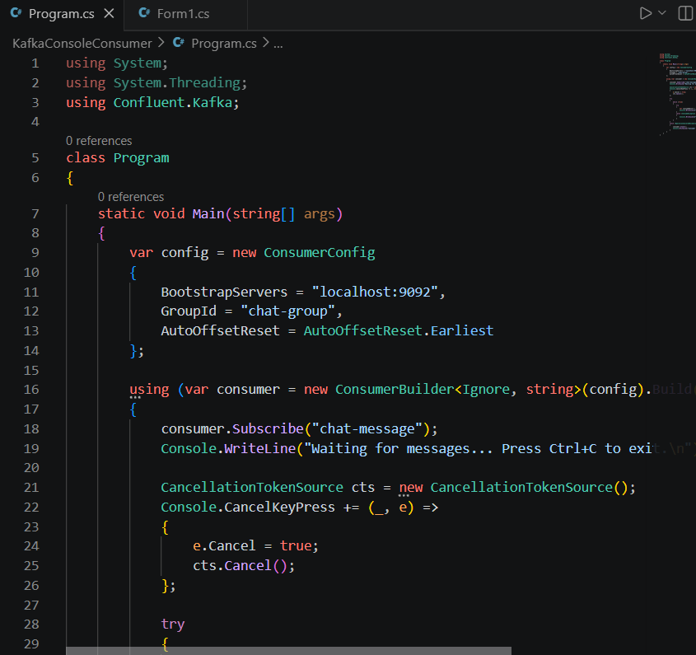

Code Snippet for Hands-On 2: Windows Forms Producer Client App (Form1.cs) –
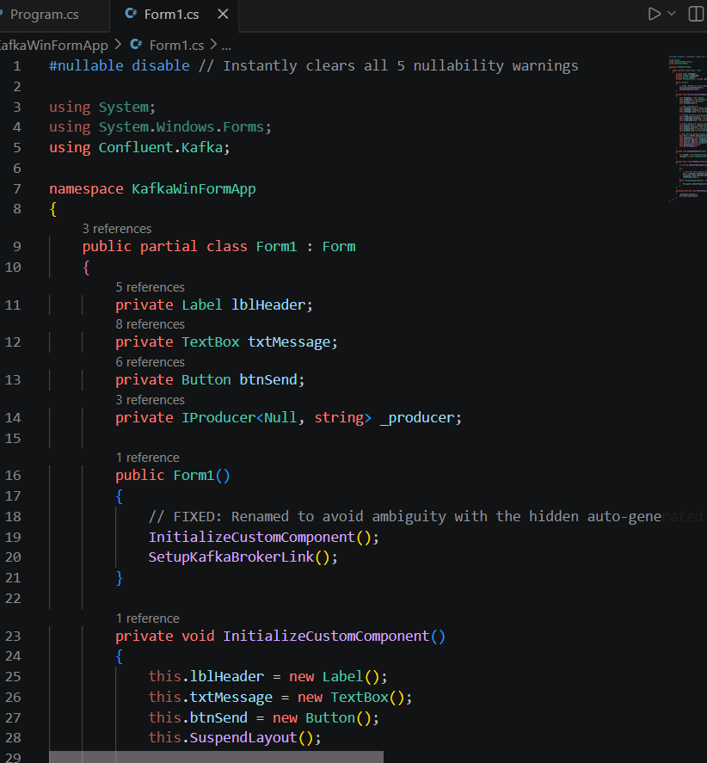

OUTPUT:
Kafka server
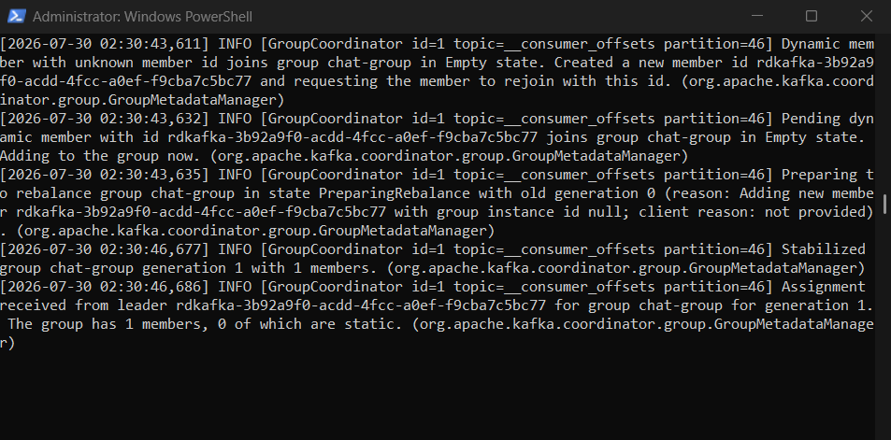
Created topic chat-message –
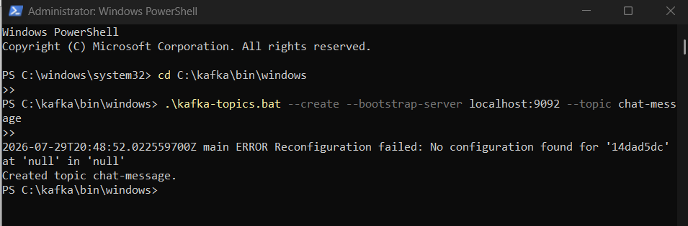

Console Chat App –
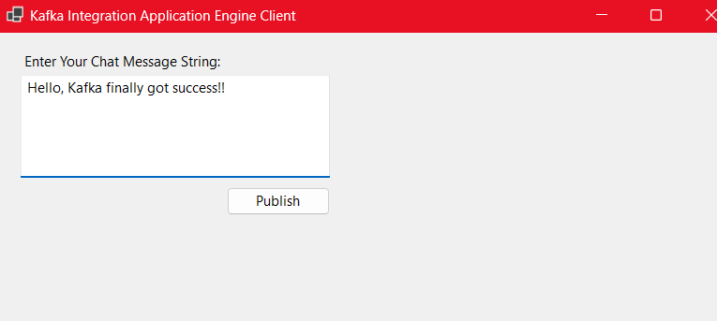
Kafka Consumer Console –
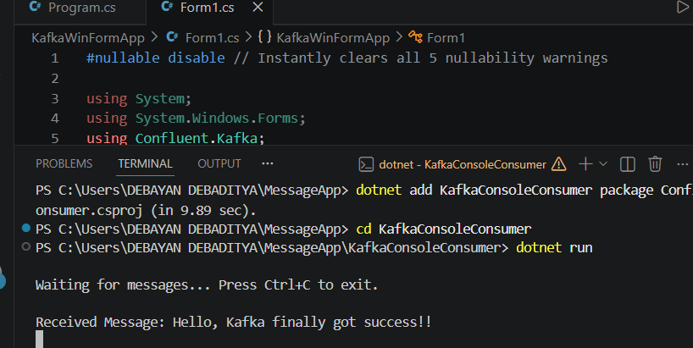

All together output -
